Join Table

Worksheet 4

Nama : Mochammad Fathan Fadillah

SOAL 4.1

Tampilkan data berikut menggunakan join table:

|  |  |  |  |  |  |  |
| --- | --- | --- | --- | --- | --- | --- |
| **Pesanan** | | | **Pelanggan** | | **Kartu** | |
| id | tanggal | total | kode | nama | nama kartu | diskon |

select pesanan.id, pesanan.tanggal, pesanan.total, pelanggan.kode,

-> pelanggan.nama, kartu.nama as nama_kartu, kartu.diskon

-> from pesanan inner join pelanggan on pesanan.pelanggan_id = pelanggan.id

-> inner join kartu on pelanggan.kartu_id = kartu.id;

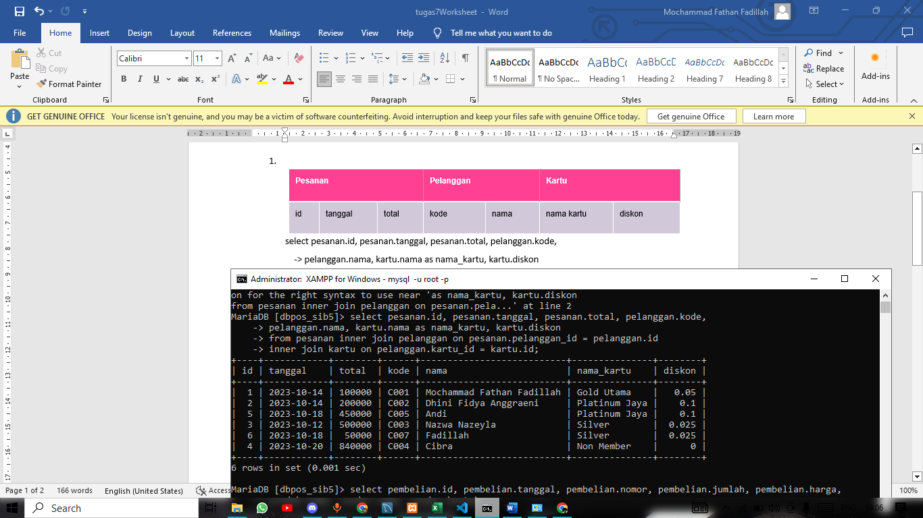

|  |  |  |  |  |  |  |  |
| --- | --- | --- | --- | --- | --- | --- | --- |
| **Pembelian** | | | | | **Produk** | **Vendor** | |
| id | tanggal | nomor | jumlah | harga | nama | nama | kontak |

select pembelian.id, pembelian.tanggal, pembelian.nomor, pembelian.jumlah, pembelian.harga,

-> produk.nama as nama_produk, vendor.nama as nama_vendor, vendor.kontak

-> from pembelian inner join produk on pembelian.produk_id = produk.id

-> inner join vendor on pembelian.vendor_id = vendor.id;

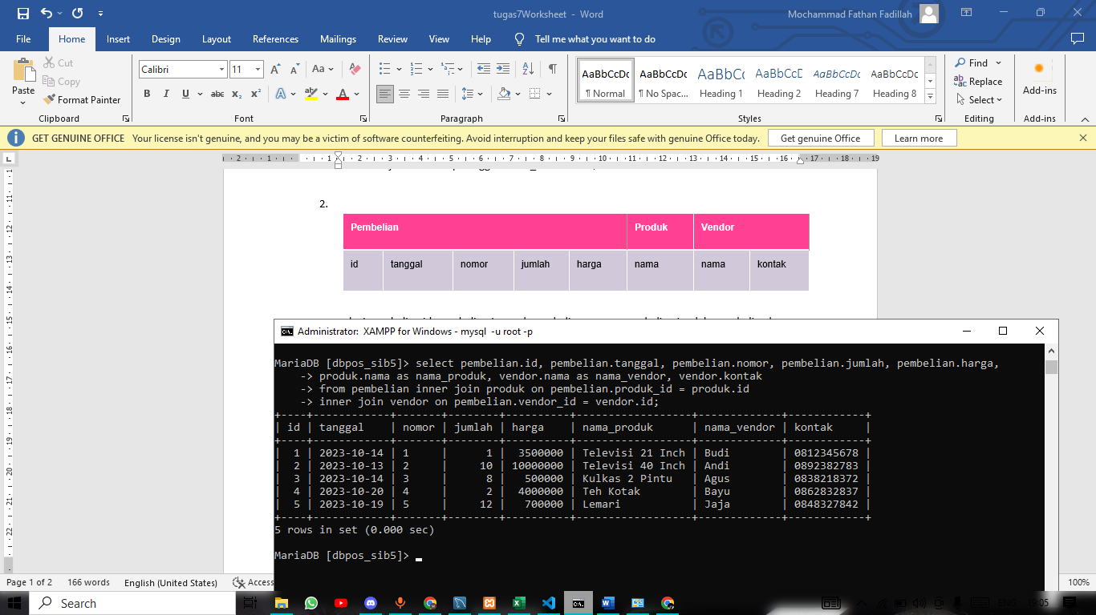

|  |  |  |  |  |  |  |  |  |
| --- | --- | --- | --- | --- | --- | --- | --- | --- |
| **Pesanan** | | | **Pelanggan** | **Produk** | | **Jenis produk** | **Pesanan items** | |
| id | tanggal | total | nama | kode | nama | nama | qty | harga_jual |

SELECT pesanan.id, pesanan.tanggal, pesanan.total, pelanggan.nama,

-> produk.kode, produk.nama as nama_produk, jenis_produk.nama, pesanan_items.qty, pesanan_items.harga

-> from pesanan inner join pelanggan on pesanan.pelanggan_id = pelanggan.id

-> inner join produk on pesanan.produk_id = produk.id

-> inner join jenis_produk on produk.jenis_produk_id = jenis_produk.id

-> inner join pesanan_items on pesanan.pesanan_items_id = pesanan_items.id;

